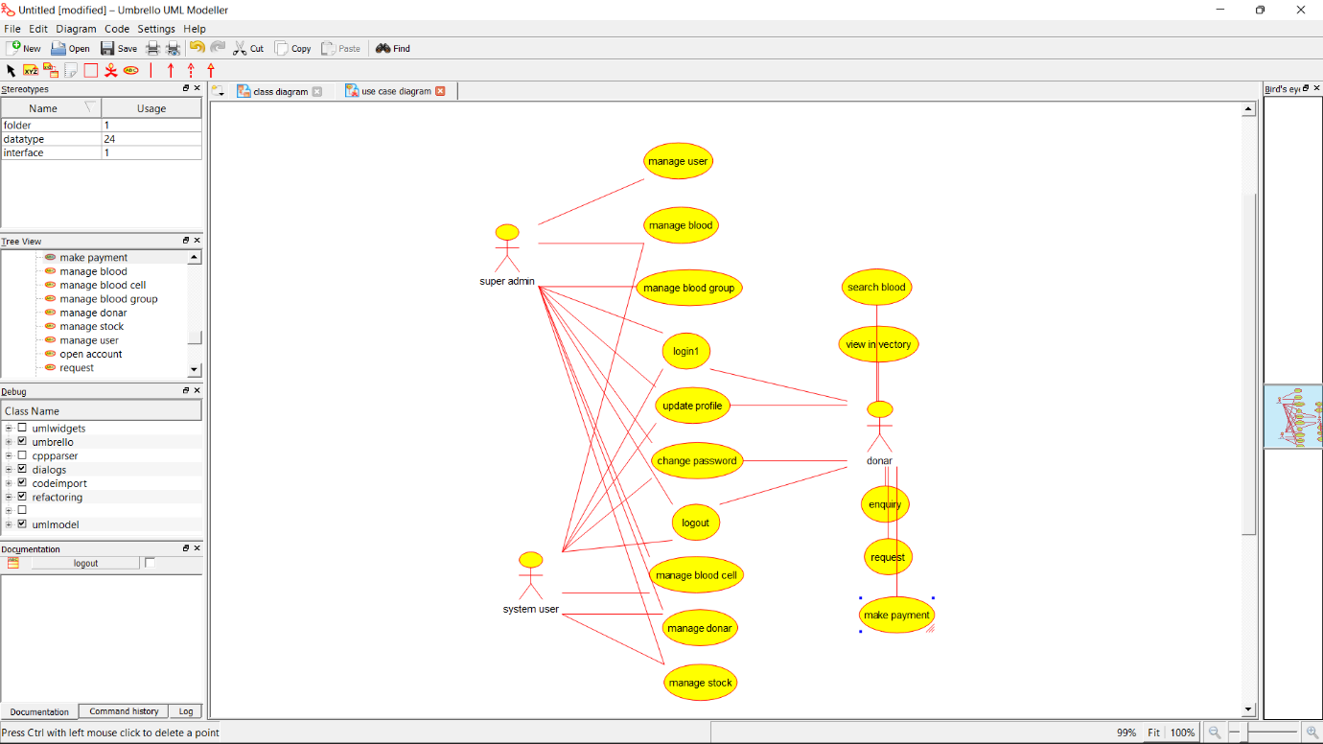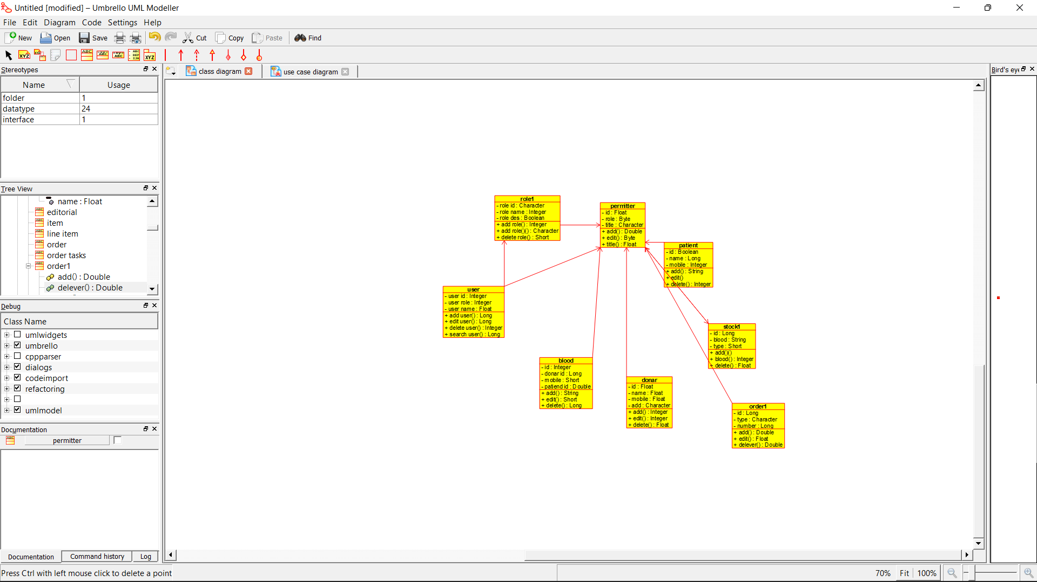

**Source Code:**

import java.util.*;

/**

* Class billing_page

*/

public class billing_page {

//

// Fields

//

//

// Constructors

//

public billing_page () { };

//

// Methods

//

//

// Accessor methods

//

//

// Other methods

//

}

/**

* Class blood

*/

public class blood {

//

// Fields

//

private Integer id;

private Long donar_id;

private Short mobile;

private Double patiend_id;

//

// Constructors

//

public blood () { };

//

// Methods

//

//

// Accessor methods

//

/**

* Set the value of id

* @param newVar the new value of id

*/

private void setId (Integer newVar) {

id = newVar;

}

/**

* Get the value of id

* @return the value of id

*/

private Integer getId () {

return id;

}

/**

* Set the value of donar_id

* @param newVar the new value of donar_id

*/

private void setDonar_id (Long newVar) {

donar_id = newVar;

}

/**

* Get the value of donar_id

* @return the value of donar_id

*/

private Long getDonar_id () {

return donar_id;

}

/**

* Set the value of mobile

* @param newVar the new value of mobile

*/

private void setMobile (Short newVar) {

mobile = newVar;

}

/**

* Get the value of mobile

* @return the value of mobile

*/

private Short getMobile () {

return mobile;

}

/**

* Set the value of patiend_id

* @param newVar the new value of patiend_id

*/

private void setPatiend_id (Double newVar) {

patiend_id = newVar;

}

/**

* Get the value of patiend_id

* @return the value of patiend_id

*/

private Double getPatiend_id () {

return patiend_id;

}

//

// Other methods

//

/**

* @return String

*/

public String add()

{

}

/**

* @return Short

*/

public Short edit()

{

}

/**

* @return Long

*/

public Long delete()

{

}